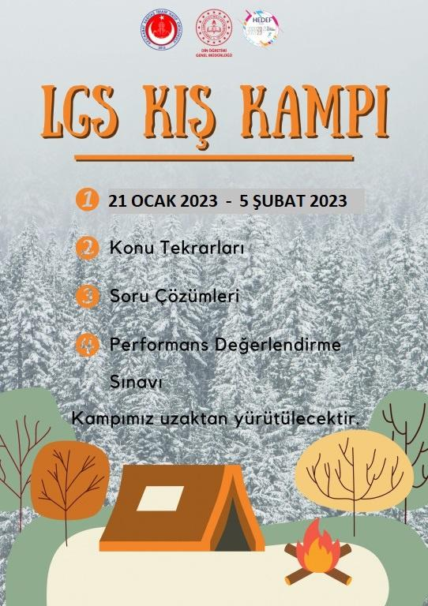
17 NİSAN 2023 – 22 NİSAN 2023
LGS ARA KAMPI

